Risk Management in Banking System
Name of student
Name of tutor
The institution of affiliation
Date

Banks serve an important purpose in any economy. Among other things, banks provide fundamental services to consumers, businesses entities and governments in order to run their businesses. Essentially, the banking system is the cornerstone to sustainable economic development. Risk is present in all aspects of our life today and the banking system is not an exception (Tursoy, 2018). Until recently, because of the regulated environment, banks were not willing to take risks. But today, the existence of stiff competition in the market has forced banks to accomodate some form of financial and non-financial risks. Risks and uncertainties form an integral part of the banking system which it essentially implies taking risks. There are several risks inherent in the banking industry that has warranted banks to take effective measures to curtail them.
Credit risk is one of the major risks for banks. This happens when borrowers are unable to fail to honor their contractual agreement with the bank. An example is when a borrower fails to pay interest on their loan. Defaults can happen to mortgages, credit cards and securities. Another risk inherent in the banking system is operational risk. This is the risk of loss as a result of errors or damages caused by individuals, systems or processes. For example, fraud perpetrated by hackers can lead to banks loosing a lot of money and also trust from customers. Furthemore, banks also face market risks. This type of risk occurs from a bank's activities in capital markets. This comes as a result of unpredictability of equity markets, prices on goods, and interest rates. Banks are more vulnerable if they invest heavily in capital markets.
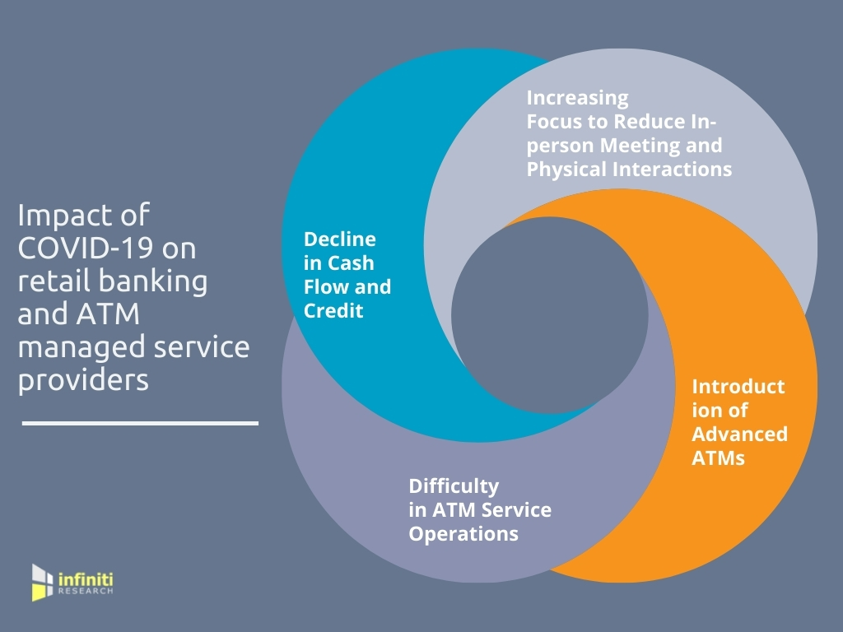
Recent statistics in the market indicate that Covid-19 pandemic has had a significant impact on operations in the banking system. The pandemic has exposed risks that banks must be prepared to tackle in case of such eventualities. A recent report in Economic Times has shed light on how the banking system has been affected by Covid-19 and this is expected to continue. Statistics indicate that low interest rate is making banks loose profits in mature markets (Mok, 2017). Many people are seeking funds from banks to seek better health care during this pandemic period. The immediate effect of this on global economy is increased credit risk of corporate and retail clients of the banks. High volatility in stock markets has depressed banks in capital markets. The statistics indicate that indeed bank valuations are dropping across the globe. Banks stocks are falling as price slump increases. In addition, this period has exposed the risk of bank's relationship with their customers. Banks during this period have been forced to demonstrate their ability to provide convenient services to their customers. This is due to the fact that they need to demonstrate the ability to provide services to customers unable to travel due to COVID-19 restrictions. Most banks have been forced to look into venturing in digital platforms to improve customer relationship.
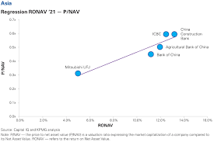
The statistics presented about the risk management in the banking system can help banks prepare for eventualities like COVID-19. This statistics can help banks to find ways to mitigate risks. Today, banks are looking into the possibility of using artificial intelligence technologies can improve risk management. The statistics have proved the existence of disconnect between banks and customers in the event customers are unable to access banks physically due to travel restrictions. Therefore, banks can look into the possibility of investmenting heavily in digital infrastructure to improve customer relationship. Also, this information is important for banks to find ways to manage relationship with employees.
The pandemic proved as a risk to banks in the case of employees being forced to work from home. This poses an operational risk because banks that have not invested heavily in digital online platforms can no longer provide the much needed services to their customers. Finally it is evident that the COVID-19 pandemic has had devastating effects on the operations of banks. And in my opinion, this information presented about risk management is important in proving the risks bank face in the event of eventualities. I support the view that banks today should invest heavily in digital technology in order to prevent operational risks. Managing risks is important for continuous operations in the banking system.

References
https://home.kpmg/xx/en/home/insights/2020/07/covid-19-impact-on-banking-m-and-a-2020.html
Mok, A., & Saha, R. (2017). Strategic risk management in banking. Deloitte Inside Magazine, 1(1), 1-16.
Tursoy, T. (2018). Risk management process in banking industry.

